Tarih: 18/10/2024

LİSANSÜSTÜ TEZ ÖNERİSİ
YÜKSEK LİSANS | DOKTORA

Tezin Yapılacağı  Ana Bilim Dalı / Ana Sanat Dalı | Textile Engineering
TEZ DANIŞMANI
Adı Soyadı | Prof. Dr. Nihat ÇELİK
Ana Bilim Dalı / Ana Sanat Dalı | Textile Engineering
İKİNCİ TEZ DANIŞMANI
(varsa)
Adı Soyadı
Ana Bilim Dalı / Ana Sanat Dalı
ÖĞRENCİNİN
Adı Soyadı | Sharif Ahmed
Öğrenci No | 2022913127
Ana Bilim Dalı / Ana Sanat Dalı | Textile Engineering
Tezin Adı | Yapay Zeka ve Görüntü İşleme Kullanılarak Yenilikçi İplik Özelliği Analizi: Çap, Büküm, Tüylülük ve Yoğunluk Ölçümüne Kapsamlı Bir Yaklaşım
Tezin İngilizce veya Diğer Dilde Adı | Innovative Yarn Property Analysis Using Image Processing and Artificial Intelligence: A Comprehensive Approach to Diameter, Twist, Hairiness and Compactness Measurement

NOT: Tez danışmanı veya tez konusu değişikliklerinde bu FORM yeniden doldurulur.

1) ARAŞTIRMA PROBLEMİ VE GEREKÇESİ
Bu kısımda araştırma probleminin kısaca tanımlanması, nitel ve/veya nicel ayrıntıları ile araştırılacak biçimde ifade edilerek araştırma probleminin çözümü için neden bu araştırmanın yapılmasına gereksinim duyulduğunun açıklanması istenmektedir.
The textile industry is one of the largest global industries, and the quality of its products, such as yarn, plays a crucial role in determining the final output's performance, appearance, and durability. Yarn properties like diameter, twist, and hairiness significantly affect the fabric's strength, elasticity, and comfort, making accurate measurement and control of these properties essential for maintaining high standards in textile manufacturing (Adanur, 2020; Chen et al., 2014).
Traditional methods for evaluating yarn properties, such as capacitive testing for unevenness and mechanical testing for twist and optical measurement of hairiness, have several limitations (Kincal, 1998). For example, yarn diameter, a critical factor influencing yarn strength and fabric quality, is often not measured directly in conventional systems (Mishra and Mukhopadhyay, 2008). Instead, indirect methods are used, which can result in inaccurate assessments and missed defects. Furthermore, current systems rely on measuring the average twist per inch, which may not capture the true twist distribution along the yarn axis, leading to potential errors in quality control (Kumar et al., 2016).
While yarn linear density or count is commonly used to quantify yarn thickness, it doesn't directly correspond to the actual diameter of the yarn. This is because yarns of the same count can have varying diameters due to differences in fiber composition, structure, and processing methods. Factors such as fiber fineness, crimp, twist level, and yarn compaction can all influence the relationship between count and diameter (Kothari, 2009). As a result, relying solely on count to assess yarn diameter can be misleading, especially when precision and consistency are critical in textile applications. To address the limitations of traditional methods for measuring yarn diameter, this research will employ advanced image analysis techniques (Fu et al., 2019). By automatically detecting and measuring the yarn's cross-sectional area, an accurate estimation of its diameter can be obtained. This approach eliminates the need for manual measurements and ensures greater consistency and precision.
Yarn evenness, a crucial factor in yarn quality, is traditionally measured by assessing capacitance variations along the yarn (Ozer, 2021). Our innovative system offers a more precise approach. By analyzing images of yarn cross-sections, we can measure the diameter of every segment, even those less than a millimeter long. This granular data allows for a more accurate calculation of unevenness, leading to a superior understanding of yarn quality.
Yarn twist is a crucial property that significantly influences the performance and characteristics of textile fabrics (Demiryurek et al., 2018). It affects factors such as yarn strength, elasticity, bulk, and handfeel. Twist can also impact the behavior of yarns during processing operations like weaving, knitting, and dyeing (Hearle et al., 1969). A well-balanced twist level is essential for achieving optimal yarn properties and ensuring the production of high-quality textiles. Currently, yarn twist is primarily measured indirectly by untwisting the yarn (Behera and Mishra, 2006). This method involves manually or mechanically unwinding the yarn and counting the number of turns per unit length. However, this technique does not provide information about the distribution of twist along the yarn. To address the limitations of traditional yarn twist measurement methods, this research proposes a more accurate and efficient approach by analyzing clear images of the yarn and automatically measuring the twist angle.
Yarn hairiness is a critical property that significantly impacts the overall quality and performance of textiles (Telli, 2017). It influences factors such as yarn appearance, strength, evenness, and other essential characteristics. Hairiness can also affect the processing of yarns, including weaving, knitting, and dyeing (Süel et al., 2009). Yarn hairiness is primarily measured using optical methods. However, this indirect approach can introduce inaccuracies as it doesn't directly measure the actual hair length. In this research, a more accurate and straightforward approach to measuring yarn hairiness will be employed through image analysis.
Yarn compactness (closeness of the fibers within a yarn) is also an important property of yarn which influences strength, durability, handfeel, and appearance of yarn (Pan, 2015). Microscopic examination and image analysis are key methods of compactness measurement. There don’t have too many mentionable works on measuring this property. The determination of compactness of the yarn will be conducted using image analysis techniques.
With advancements in digital imaging and computational power, image analysis has emerged as a powerful tool for non-destructive testing in various industries (Kim et al., 2016). In the context of textiles, image analysis can offer direct and precise measurements of yarn properties, such as diameter and twist, providing a more accurate representation of the yarn's quality (Haleem et al., 2019).
Given the importance of these factors, the development of an image-based yarn analysis system represents a significant step forward in textile technology. It addresses critical gaps in current testing methods and offers a more efficient, accurate, and sustainable approach to quality control (Zhang et al., 2020).

2) ARAŞTIRMANIN AMACI
Bu kısımda problem cümlesine paralel olarak araştırmanın genel amacının, varsa araştırmanın kavramsal modelinin ve hangi değişkenlerde hangi verilerin toplanacağını belirleyen ayrıntılı alt amaçlarının soru veya hipotez şeklinde açık ve net olarak ifade edilmesi istenmektedir.
This thesis aims to develop an innovative system for analyzing yarn properties using image processing and artificial intelligence techniques, focusing on characteristics like diameter, twist, hairiness, and compactness that are crucial for fabric quality. Traditional testing methods, such as capacitive testing for unevenness, mechanical testing for twist, and optical measurement for hairiness, have limitations in accuracy and can be costly due to the need for multiple specialized machines. Our system addresses these limitations by employing high-resolution image analysis to directly measure yarn properties, providing a comprehensive assessment that captures intricate variations often missed by conventional methods. By integrating multiple testing functions into a single platform, this approach will reduce the reliance on high-cost testing machinery. Custom software will be developed to facilitate testing all properties in one place, incorporating artificial intelligence to automatically identify these properties from images. Additionally, under this thesis a yarn image dataset will be created, enhancing the accuracy and efficiency of the analysis. The developed system may speed up the testing processes, reduce the operational costs and improve the quality control in yarn manufacturing.

Objectives:
- To Develop a Image Analysis System:
  - Design and implement a image analysis system capable of accurately measuring yarn properties such as diameter, twist, hairiness, and compactness.
  - Ensure the system captures intricate variations and defects that traditional methods often miss.
- To Integrate Multiple Testing Functions into a Single Platform:
  - Combine the measurement functions for yarn diameter, twist, hairiness, and compactness into a unified image-based analysis platform.
  - Evaluate the effectiveness of this integrated approach in reducing the need for multiple specialized testing machines.
- To Develop Custom Software with Artificial Intelligence:
  - Create custom software that utilizes artificial intelligence to automatically identify and analyze yarn properties from images.
  - Test and validate the software’s performance in comparison to traditional testing methods.
- To Create a Yarn Image Dataset:
  - Compile a comprehensive dataset of yarn images to support the development and validation of the image analysis system and AI algorithms.
  - Use this dataset to enhance the precision and reliability of yarn property measurements.
- To Develop a Non-Destructive and Environmentally Friendly System:
  - Create a non-destructive system which will reduce waste and operational costs.

3) ARAŞTIRMANIN ÖNEMİ
Bu kısımda araştırmadan elde edilecek sonuçların kuramsal olarak ilgili alanyazına (literatüre) sağlayacağı/sağlaması beklenilen özgün katkıları ile bu sonuçların uygulamada nerede ve nasıl kullanılacağının açıklanması istenmektedir.
Innovative Contributions to Textile Engineering:
This research will bring significant contributions to textile engineering by developing an AI-powered system for yarn property analysis, offering a novel approach to textile quality control. The research will shift measurement techniques from traditional, indirect methods to direct, image-based assessments, increasing the accuracy and reliability of yarn property evaluation. By integrating image processing and AI, the research will influence broader fields such as automation and industrial applications of AI, providing a new framework for textile testing.

Operational Efficiency and Environmental Sustainability:
In terms of practical outcomes, the proposed system will reduce operational costs by consolidating multiple testing functions into a single platform, improving efficiency and reducing reliance on expensive, specialized machines. This will lead to enhanced fabric quality through more accurate yarn assessments, while also contributing to environmental sustainability by minimizing waste during production processes.

Economic Impact and Global Competitiveness:
Furthermore, the research will have a significant economic impact by providing cost-effective quality control solutions that can be scaled globally. It will create new opportunities for skilled jobs in textile technology and software development, while improving the competitiveness of domestic textile products in the global market. By enhancing export potential and attracting foreign investment, this research will boost the economic growth of the textile industry.

Social, Cultural, and National Impact:
The social and cultural impact will be notable as well, with contributions to the sustainability of textile manufacturing and the provision of educational opportunities for students and researchers. Finally, the research will strengthen economic security by promoting resource efficiency and innovation in the textile sector, reducing dependence on imported technologies, and fostering domestic industry growth.

4) VARSAYIMLAR (SAYILTILAR) (varsa)
Bu kısımda araştırmanın kanıtlamaya gerek görmeden doğru kabul ettiği başlangıç noktalarının ifade edilmesi istenmektedir.
- The yarn properties being measured (diameter, twist, hairiness, and compactness) can be accurately captured through image analysis.
- High-resolution images will provide sufficient detail for AI algorithms to identify and measure the relevant properties.

5) SINIRLILIKLAR (varsa)
Bu kısımda araştırma bulgularının geçerli olacağı alanı belirleyen sınırlılıkların (kısıtların) ifade edilmesi istenmektedir. Araştırmacının ideal gördüğü ve normal olarak yapmak isteyip de çeşitli nedenlerle vazgeçmek zorunda kaldığı durumlar araştırmanın sınırlılıklarıdır.
- The image-based system may face challenges in handling certain environmental factors (e.g., lighting conditions, image noise) that could affect measurement accuracy.
- The precision of the system could vary across different types of yarn, particularly in cases of non-uniform fiber compositions or special yarn structures.
- There may be limitations in detecting hairiness or compactness in yarns with very fine or complex structures.

6) KURAMSAL AÇIKLAMALAR VE İLGİLİ ARAŞTIRMALAR
Bu kısımda araştırılacak konunun tarihçesi ve alanyazındaki (literatürdeki) yerinin konuyu ilgili alanla bütünleştirecek, sınırlarını çizecek ve araştırma problemini tanımlayacak şekilde sunulması ve ilgili alanyazında şu ana kadar yapılmış ve ulaşılabilen araştırmaların kronolojik olarak özetlenmesi istenmektedir.
In the literature on image analysis of yarn properties, several studies have demonstrated innovative approaches to measuring and analyzing various yarn characteristics, such as diameter, unevenness, twist, hairiness, and internal structure. These studies highlight the advancements in utilizing image processing techniques and artificial intelligence to improve yarn quality assessment, but also point out gaps that require further investigation.
A low-cost yarn parameterization unit was developed (Sengupta et al.,2014) employing image processing to measure yarn parameters like diameter and hairiness. This system, tested on jute and cotton yarns, demonstrated affordability and reliability, offering an alternative to existing commercial testers. An image analysis system was presented (Cybulska, 1999) for assessing yarn thickness, providing a non-destructive means of evaluation. A group of Researchers (Zhang et al.,1998) focused on detecting yarn thin places and unevenness through an image-analysis program, aiding in the identification of structural irregularities. In another study, a computer vision-based system was presented for online quality control, detecting defects in real-time during yarn production (Haleem et al., 2021). The importance of characterizing yarn diameter was emphasized using various commercial instruments and proposing a bimodal distribution for accurate measurement (Ibrahim et al., 2023). An adaptive median filtering denoising algorithm for yarn diameter and unevenness measurement was introduced, yielding consistent results with traditional methods (Wang et al., 2020). A method using image processing and artificial neural networks for evaluating carded cotton yarn diameter was proposed, demonstrating superior accuracy over traditional methods (Khaddama et al.,2022). A robust image processing method for measuring yarn diameter was developed, showing effectiveness comparable to the Uster Evenness Tester (Eldessouki et al., 2023). Despite these advancements, the gap remains in standardizing image analysis methods for yarn diameter and unevenness, ensuring consistency across different instruments and algorithms. Additionally, real-time application of these techniques in industrial settings requires further exploration.
Image analysis for measuring yarn diameter and twist provided valuable insights into yarn properties for quality control (Basu et al., 2003). Investigation into yarn twist measurement through digital imaging techniques introduced a hybrid method that offered superior accuracy (Ozkaya et al., 2010). An optical method-based system for continuous measurement of yarn structures, including twist distribution, was presented (Guo et al., 2010). Although these studies provide efficient methods for twist measurement, there is still a need for techniques that can handle various yarn types and production conditions. Moreover, integrating these methods into a comprehensive system for online monitoring in textile manufacturing remains an open challenge.
A computer vision method with a two-scale attention model was introduced for intelligent evaluation of yarn surface qualities, achieving high accuracy in yarn classification (Yan et al., 2023). A mechatronic prototype using the YOLOv5 algorithm for analyzing and classifying yarn hairiness was developed, demonstrating high precision in quality evaluation (Pereira et al., 2023). An online measurement method for sizing yarn hairiness using a multiscale Hessian feature algorithm was proposed, achieving a significant correlation with commercial testers (Guo et al., 2023). While significant progress has been made in yarn hairiness evaluation, further research is needed to refine these methods for different yarn types and production environments. Enhancing the robustness and accuracy of hairiness measurement in real-time applications remains a focus for future work.
An image analysis method was proposed for predicting intra-yarn porosity, contributing to a deeper understanding of yarn structure (Turan et al., 2012). An intelligent system for evaluating internal structural properties of cellulosic yarns was introduced, demonstrating higher efficiency than manual methods (Li and Fu, 2021). The structure of cotton ring-spun yarns was investigated using micro CT and digital image processing (Haleem et al., 2019). Despite these advancements, challenges persist in accurately analyzing yarn porosity and internal structure, particularly in non-invasive techniques. Future research should focus on developing more refined image analysis methods for comprehensive and accurate evaluation of these properties in various yarn types.
Our work aims to address these gaps by developing a comprehensive system for analyzing multiple yarn properties, including diameter, twist, hairiness, compactness, twist direction, and diameter distribution. Unlike previous studies that often focus on a single parameter or rely on expensive commercial equipment, our approach will use a low-cost setup with a microscopic camera, scanner, and custom software incorporating artificial intelligence. This system will offer a more holistic analysis of yarn properties, overcoming limitations in versatility, accuracy, and real-time applicability. By employing advanced image processing techniques like OpenCV and Scikit-learn, we aim to create an adaptable and reliable solution suitable for various yarn types and production environments.
In the context of yarn analysis, the literature suggests that while numerous methodologies have been developed for measuring specific characteristics, there remains a need for a more integrated and versatile approach. Most previous studies have concentrated on individual yarn characteristics; our research intends to provide a unified platform for analyzing multiple properties simultaneously. This approach will enable more detailed and accurate insights into yarn quality, thereby improving efficiency in textile production. By developing a novel yarn image dataset and collaborating with industry experts, our work aims to set a new standard for yarn analysis, potentially leading to articles and patents.

7) ARAŞTIRMANIN YÖNTEMİ
Bu kısımda araştırmanın modeli, araştırma evreni, örneklemi, veri toplamada kullanılacak araçlar ve bu araçların geçerlik-güvenirlik çalışmaları ile verilerin çözümlenmesinde kullanılacak tekniklerin açıklanması beklenmektedir. Çalışmada uygulanacak yöntemler ile kullanılacak materyaller kullanılma gerekçeleriyle birlikte açık-seçik biçimde tanımlanır. Yapılacak ölçümler ya da retrospektif veya ankete dayalı derlenecek veriler, kurulacak ilişkiler ayrıntılı biçimde anlatılır. Anket veya geriye dönük çalışmalarda örneklerin alınacağı popülasyon gerekçeleri ile belirtilir. Kullanılacak anket formu eklenir, kullanılma gerekçesi açıklanır. Verilerin değerlendirilmesinde kullanılacak istatiksel analiz türleri kullanılma gerekçeleri ile belirtilir.
This research aims to develop an innovative system for analyzing yarn properties using advanced image processing techniques. The methodology includes several key components: image acquisition, image processing, data analysis, and validation. The methods and research techniques are outlined below, including references to related literature and the association with research work packages (WP). At last preleminary/feasibility study is also added.

Image Acquisition:
A high-resolution camera will be utilized to capture detailed images of the yarn. The camera’s resolution will be selected to ensure clarity and accuracy in measuring yarn properties. The images will be taken under controlled lighting conditions to minimize shadows and reflections that could affect the measurements. Figure 1 shows image acquisition setup where, a computer is connected to a high-resolution camera that captures images of the yarn. The yarn moves continuously, guided by rollers, ensuring smooth passage through the camera’s field of view. These guide rollers are powered by a stepper motor, which controls the movement speed of the yarn. The stepper motor is supplied with power from a dedicated power source. The speed of the motor, and thus the yarn movement, is regulated by a Raspberry Pi, ensuring precise control over the image acquisition process.

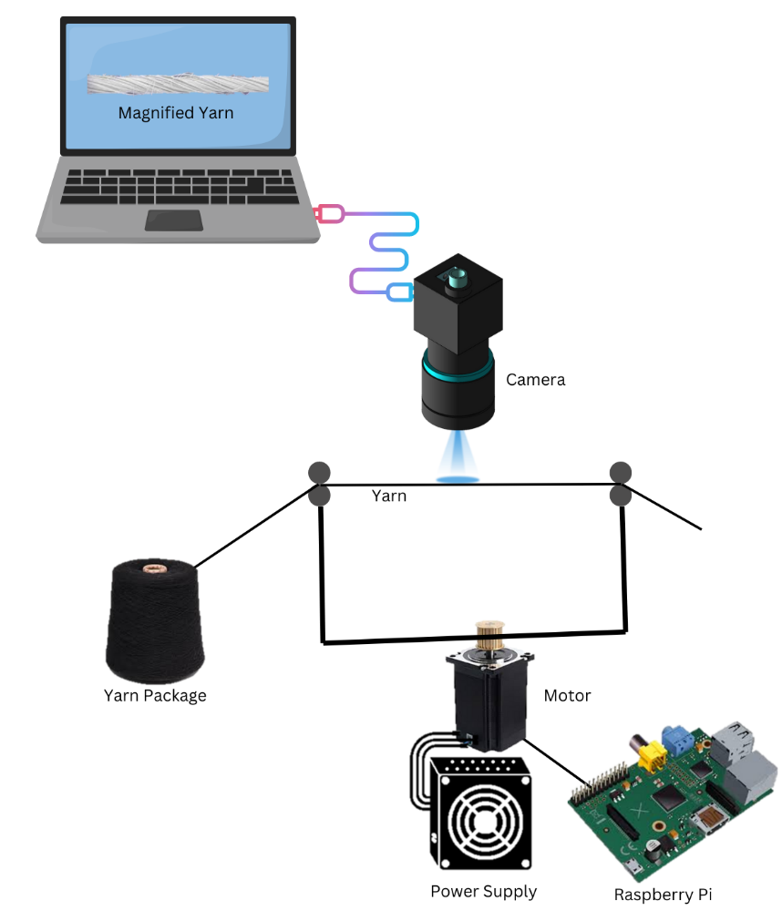
Figure 1: Experimental setup for image acquisition

Figure 2 shows the sequence of measuring yarn diameter, hairiness and twist.

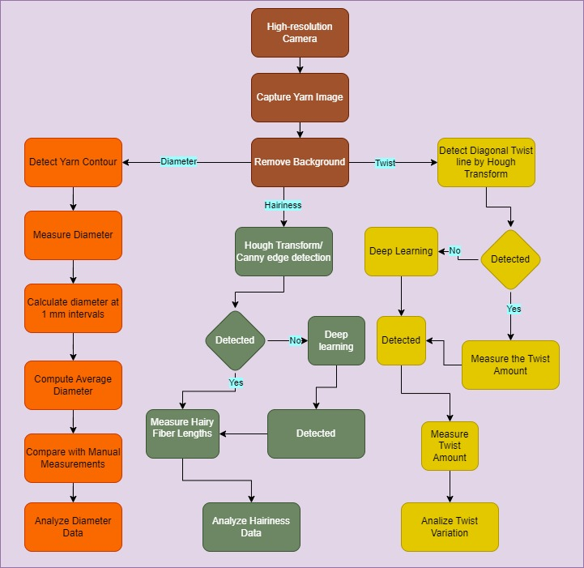
Figure 2: Flowchart of yarn diameter, hairiness and twist measurement

Diameter Measurement Procedure:
- Image Preprocessing: A custom program will be developed using Python to preprocess the images. This program will use libraries such as OpenCV to remove the background and enhance the contrast of the yarn contour (OpenCV Documentation, 2024).
- Contour Detection: The program will detect the edge of the yarn using edge detection techniques such as the Canny edge detector(Canny, 1986). The contours will be analyzed to identify the yarn's boundary.
- Diameter Calculation: The diameter will be calculated at 1 mm intervals along the yarn axis using geometric methods. The average diameter will be computed and compared with manual measurements to assess accuracy. Diameter variation will be determined based on the collected data.

Twist Measurement Procedure:
- Angle Detection: The program will use the Hough Line Transform to detect diagonal lines on the yarn, representing the twist. The twist per unit length will be calculated based on these detected angles (Hough & P. V. C.,1962; Yuen & Green, 1990).
- Validation: The twist measurements will be compared with manual and machine testing results to verify accuracy. Twist variation will be analyzed using statistical methods.

Hairiness Measurement Procedure:
- Contour Analysis: The program will identify hairy fibers by analyzing the contour of the yarn. If the initial identification is insufficient, a deep learning approach will be implemented using convolutional neural networks (CNNs) to improve accuracy (LeCun, Y., et al., 1998; TensorFlow Documentation, 2024).
- Predefined Images: A dataset of predefined images for hairiness will be used to train and validate the deep learning model.

Cross-Sectional Analysis and Fiber Counting Procedure:
- Cross-Sectional Imaging: Cross-sectional images of the yarn will be captured to analyze the number of fibers within the yarn.
- Fiber Detection: The Hough Circular Line System will be employed to detect and count fibers in the cross-section. The area of each fiber's cross-section will be calculated (Duda&Hart,1972; Scikit-image Documentation, 2024).
- Compactness Calculation: Yarn packing density or compactness will be determined based on the calculated fiber areas and cross-sectional measurements. Figure 3 shows the yarn cross-sectional analysis sequence.

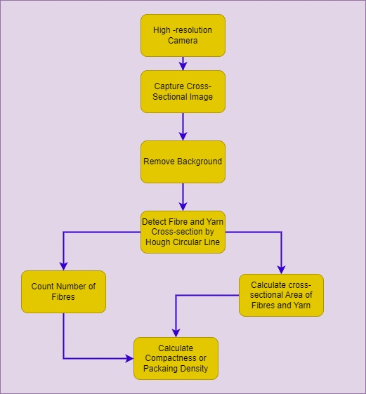
Figure 3: Yarn Cross-sectional Analysis
We will measure the compactness of the yarn and compare it with traditional measuring of compactness and we will tabulate the values to compare traditional system and our automatic system. Traditional system follows following formula:
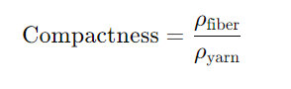
Where:
- ρ_{fiber}​ is the density of the fiber material (in g/cm³),
- ρ_{yarn}​ is the apparent density of the yarn, calculated as the mass of yarn per unit volume.

Validation and Comparison Procedure:
- Accuracy Assessment: The measurements obtained from the image analysis system will be compared with traditional manual and machine-based tests (Table1). Statistical methods will be used to assess the accuracy and reliability of the new system (Bland & Altman, 1986). Traditional tests should be carried out according to standart test methods TS 244 EN ISO 2060 (Determination of linear density (mass per unit length) by the skein method), TS EN ISO 2061 (Determination of twist in yarns-Direct counting method), TS 12863 ASTM D5647 (Determination of hairness of yarns- Photo- Electric method), ISO 16549 (Unevenness of textile strands — Capacitance method) and SEM Imaging.
- Feasibility Study: Preliminary work for diameter calculation has already ben conducted to evaluate the feasibility of the proposed methods and it worked accurately.

Table 1: sample properties comparison table of traditional and our developed system
Sample No | Diameter  (mm) |  | Twist Level  (TPI) |  | Unevenness  (%CV) |  | Hairiness  (H) |  | Compactness  (%)
Sample No | Traditional Way | Developed System | Traditional Way | Developed System | Traditional Way | Developed System | Traditional Way | Developed System | Traditional Way | Developed System
1
2
3
.
.
.
50

8 ) ARAŞTIRMA OLANAKLARI
Tez çalışmasının yapılacağı yerler (laboratuvar, klinik, birim, kurum) ve bu yerlerin özellikleri ile var olan ve Tez çalışmasında kullanılacak alt yapı olanakları yazılır ve/veya Tablo halinde verilir.
Table 2: Places of thesis study
Infrastructure/equipment type, model available in the organization  (Laboratory, Machinery-equipment, etc.) | Purpose of Use in the Research
Cukurova University Textile Engineering Department Lab. | The main facility for conducting the majority of the research work, including preliminary imaging and sample analysis using the available high-resolution camera.
Cukurova University Textile Engineering Department Lab. | Used for testing yarn count and twist to validate the automated measurements against traditional methods.  Also for testing yarn evenness and hairiness to validate the automated measurements against traditional methods.
Scanning Electron Microscope (SEM) at the Central Laboratory of Cukurova University | Utilized for detailed yarn cross-sectional analysis and compactness evaluation to gain insights into fiber distribution and packing density.

9) ARAŞTIRMANIN ÖNGÖRÜLEN TEZ PLANI
Bu kısımda araştırmada yer alacak bölüm başlıklarını içeren genel planın verilmesi istenmektedir.
The thesis will follow a comprehensive structure, with each chapter covering key aspects of the research:
- Introduction
  - Background of the Study: Overview of yarn property analysis in textile manufacturing and the current limitations of traditional testing methods.
  - Problem Statement: The challenges with existing indirect methods of measuring yarn properties such as diameter, twist, hairiness, and compactness.
  - Objectives of the Research: The purpose of developing an AI-powered system for direct yarn property measurement using image processing.
  - Significance of the Study: Importance of the research for the textile industry, its impact on operational efficiency, and its contribution to sustainability.
- Literature Review
  - Overview of Yarn Testing Techniques: Analysis of traditional methods such as capacitive testing for unevenness, mechanical testing for twist, and optical methods for hairiness.
  - Image Processing in Textile Engineering: Review of existing research on image-based measurements and its applications in textiles.
  - Artificial Intelligence in Quality Control: Discussion of AI methods applied to manufacturing and their potential in automating yarn property analysis.
  - Research Gaps: Identification of shortcomings in the literature and how this research addresses those gaps.
- Research Methodology
  - Research Design: Detailed description of the experimental design, including the workflow for data collection and image analysis.
  - Image Acquisition: Methods used to capture high-resolution images of yarns under controlled conditions.
  - Development of AI Algorithms: Explanation of the AI models, such as CNNs for hairiness detection and geometric methods for diameter and twist measurement.
  - Data Collection Tools: Overview of the tools and materials used, including the imaging hardware and software.
  - Validation Methods: Statistical and comparative techniques used to validate the accuracy of the developed system against traditional testing methods.
- System Development and Design
  - Design of the Imaging System: Detailed explanation of the hardware and software components of the system, including camera setup and motor-driven yarn movement.
  - Development of Image Processing Algorithms: How algorithms like the Hough Line Transform and Canny Edge Detector are used for analyzing yarn properties.
  - Integration of Testing Functions: Implementation of a single platform capable of measuring diameter, twist, hairiness, and compactness.
  - Custom Software Development: The process of developing AI-driven software to automate the analysis of yarn properties.
- Results and Validation
  - System Performance: Presentation of results showing the system's accuracy in measuring yarn diameter, twist, hairiness, and compactness.
  - Comparison with Traditional Methods: Validation of the new system by comparing results with standard industry practices such as capacitive and mechanical testing.
  - Statistical Analysis: Application of statistical tools to analyze the system’s performance, including correlation and reliability tests.
- Discussion
  - Interpretation of Results: Critical analysis of the findings, how they meet the research objectives, and how they compare to previous studies.
  - Implications for the Textile Industry: Discussion on how the new system can improve yarn quality control, reduce costs, and increase competitiveness in the global textile market.
  - Limitations of the Research: Identification of any limitations encountered during the development and testing of the system and potential solutions.
- Conclusion and Future Work
  - Summary of Findings: Recap of the key results and contributions of the research.
  - Contributions to the Field: Overview of the original contributions made to textile engineering, AI applications, and image processing.
  - Recommendations for Future Research: Suggestions for further development of the system, including potential improvements in AI algorithms and expanding the system to other textile properties.
  - Practical Applications: Potential commercial applications and steps for industry implementation.

10) ARAŞTIRMA TAKVİMİ
Bu kısımda araştırmanın zaman çizelgesi verilmelidir.
Table 3: Timeline of the research work

Serial No. | Work Package | Period
1 | a) Literature review on yarn properties, AI, and image processing | Fall, 2024-25
1 | b) Collection of necessary materials | Fall, 2024-25
1 | c) Initial testing of imaging system and hardware setup | Fall, 2024-25
1 | d) Presentation of initial findings and research progress | Fall, 2024-25
2 | a) Development of image processing algorithms (yarn diameter, twist, hairiness) | Spring, 2025
2 | b) Testing and refinement of AI models for yarn property analysis | Spring, 2025
2 | c) Development of the integrated yarn testing platform | Spring, 2025
2 | d) Presentation on system design and algorithm development | Spring, 2025
3 | a) Full-scale yarn testing using the developed system | Fall, 2025-26
3 | b) Validation of results against traditional testing methods | Fall, 2025-26
3 | c) Fabric testing using yarn produced by the developed system | Fall, 2025-26
3 | d) Presentation on results and validation | Fall, 2025-26
4 | a) Final analysis and discussion of results | Spring, 2026
4 | b) Thesis writing | Spring, 2026
4 | c) Thesis defense and final submission | Spring, 2026

11) KISALTMALAR (varsa)
AI: Artificial Intelligence
CNN: Convolutional Neural Network
SEM: Scanning Electron Microscope
CV%: Coefficient of Variation Percentage
TPI: Twists Per Inch
OpenCV: Open-Source Computer Vision

12) ETİK KURUL İZİN BELGESİ
Tez çalışmasında yapılacak insan ve hayvan deneylerine ait etik kurul kararı eklenir.
This research does not involve human or animal research participants.

13) PROTOKOLLER VE İZİNLER
Tez çalışmasında veri toplama veya veri analizlerinin tamamı veya bir kısmı başka bir kurum/birim laboratuvarında/kliniğinde yapılacaksa veya başka kurum/birim laboratuvar/kliniğindeki verilerin geriye dönük dosya taraması yapılacaksa, bu kurum/birimle yapılan protokol veya çalışmanın kendi bilgileri dahilinde yapıldığını ifade eden evrak kayıt numarası ve tarihi bulunan kurum/birim tarafından izin verildiğini ifade eden evrak eklenir.
All the data collection and data analysis will be carried out inside the Textile Engineering Department of Cukurova University.

14) KAYNAKÇA
Adanur, S. (2020). Textile Quality and Control: Yarn Quality Measurement. Textile Research Journal, 90(3), 523-535.
Basu, R., Doraiswamy, R., & Gotipamul, M. 2003. "Measurement of Yarn Diameter and Twist by Image Analysis."
Behera, B. K., & Mishra, R. (2006). Twist Measurement in Yarn: A Critical Review. Journal of Textile Science & Engineering, 6(4), 208-217.
Bland, J. M., & Altman, D. G. (1986). "Statistical Methods for Assessing Agreement between Two Methods of Clinical Measurement." The Lancet.
Canny, J. (1986). "A Computational Approach to Edge Detection." IEEE Transactions on Pattern Analysis and Machine Intelligence.
Chen, Q., et al. (2014). Assessment of Yarn Quality Using Image Processing Techniques. Journal of Engineered Fibers and Fabrics, 9(4), 45-52.
Cybulska, E. 1999. "Assessing Yarn Structure with Image Analysis Methods."
Demiryurek, O., et al. (2018). Effect of Yarn Twist on the Mechanical Properties of Textile Fabrics. Journal of Textile Science & Engineering, 8(1), 312-318.
Duda, R. O., & Hart, P. E. (1972). "Use of the Hough Transformation to Detect Lines and Curves in Pictures." Communications of the ACM.
Eldessouki, R., et al. 2023. "A Dynamic and Robust Image Processing Based Method for Measuring the Yarn Diameter and Its Variation."
Fu, W., et al. (2019). Advanced Techniques for Yarn Diameter Measurement. Textile Research Journal, 89(11), 2285-2297.
Guo, M., et al. 2023. "Online Measurement of Sizing Yarn Hairiness Based on Computer Vision."
Guo, Y., et al. 2010. "A Continuous Measurement System for Yarn Structures by an Optical Method."
Haleem, A., et al. (2019). Image Analysis for Accurate Yarn Quality Control. Applied Mechanics and Materials, 890, 189-198.
Haleem, N., Bustreo, M., et al. 2021 "A Computer Vision-Based Online Quality Control System for Textile Yarns."
Haleem, N., et al. 2019. "Investigating the Cotton Ring Spun Yarn Structure Using Micro Computerized Tomography and Digital Image Processing Techniques."
Hearle, J. W. S., et al. (1969). Yarn Texturing Technology. Woodhead Publishing.
Hough, P. V. C. (1962). "Method and Means for Recognizing Complex Patterns." U.S. Patent 3,069,654.
Ibrahim, S., & Militky, J. 2023. "Characterization of Yarn Diameter Measured on Different Instruments."
Khaddam, M., & Ahmad, A. "A Method to Evaluate the Diameter of Carded Cotton Yarn Using Image Processing and Artificial Neural Networks."
Kim, J., et al. (2016). Advancements in Image-Based Non-Destructive Testing for Textiles. Journal of Textile and Apparel, Technology and Management, 10(3), 15-23.
Kincal, C. (1998). Yarn Quality Evaluation by Capacitive Testing. Textile Research Journal, 68(8), 603-610.
Kothari, V. K. (2009). Fiber to Fabric: The Dynamics of Yarn Structure and Properties. Woodhead Publishing.
Kumar, V., et al. (2016). Advanced Yarn Twist Measurement Techniques. Journal of Textile Science & Engineering, 6(2), 200-208.
LeCun, Y., et al. (1998). "Gradient-Based Learning Applied to Document Recognition." Proceedings of the IEEE.
Li, Y., & Fu, G. 2021. "Image Analysis and Evaluation for Internal Structural Properties of Cellulosic Yarn."
Mishra, S. P., & Mukhopadhyay, A. (2008). Yarn Diameter Measurement Techniques: A Review. Journal of Textile Science & Engineering, 5(4), 134-142.
OpenCV Documentation (2024). "Image Processing with OpenCV."
Ozer, B. (2021). Yarn Evenness Measurement and Its Importance in Quality Control. Textile Research Journal, 91(5), 560-570.
Ozkaya, Y., et al. 2010. "Yarn Twist Measurement Using Digital Imaging."
Pan, N. (2015). Yarn Compactness and Its Impact on Textile Products. Textile Progress, 47(3), 1-44.
Pereira, A., et al. 2023. "Intelligent Computer Vision System for Analysis and Characterization of Yarn Quality."
Scikit-image Documentation (2024). "Image Processing in Python."
Sengupta, et al. 2014. "Development of a Low Cost Yarn Parameterisation Unit by Image Processing."
Süel, E., et al. (2009). Impact of Yarn Hairiness on Fabric Performance. Fibres & Textiles in Eastern Europe, 17(5), 41-46.
Telli, A. (2017). Comparison of Yarn Hairiness Measurements Using Different Devices. Journal of Engineered Fibers and Fabrics, 12(1), 44-50.
TensorFlow Documentation (2024). "Deep Learning with TensorFlow."
Turan, A., et al. 2012. "Predicting Intra-Yarn Porosity by Image Analysis Method."
Wang, X., et al. 2020. "Research on Yarn Diameter and Unevenness Based on an Adaptive Median Filter Denoising Algorithm."
Yan, S., et al. 2023. "A Two-Scale Attention Model for Intelligent Evaluation of Yarn Surface Qualities with Computer Vision."
Yuen, H. K., & Green, M. (1990). "The Hough Transform: A Review." IEEE Transactions on Pattern Analysis and Machine Intelligence.
Zhang, W., Iype, C., & Oxenham, W. 1998. "Analysis of Yarn Thin Places and Unevenness with Image-Analysis."
Zhang, Y., et al. (2020). Non-Destructive Image Analysis for Yarn Quality Control. Textile Research Journal, 90(10), 1148-1160.

15) TÜRKÇE ÖZET (Türkçe dışında bir dilde yazılacak tezler için)
Bu kısım Türkçe dışında bir dilde yazılacak tezin amaç, yöntem vb. bölümlerini kapsayan yaklaşık bir sayfalık özetidir.
Proje Özeti

Bu proje, iplik özelliklerini analiz etmek için görüntü işleme ve yapay zekâ tekniklerini kullanarak, çap, büküm, tüylülük ve yoğunluk gibi kumaş kalitesi için kritik öneme sahip özelliklere odaklanan yenilikçi bir sistem geliştirmeyi hedeflemektedir. Kapasitif yöntemle düzgünsüzlük ölçümü, mekanik olarak büküm tayini ve optik yöntemlerle tüylülük ölçümü gibi geleneksel test yöntemleriyle yapılan ölçümlerde sonuçların doğruluk payı sınırlı ve her bir test için farklı test cihazı kullanımı gerektiğinden dolayı maliyetli olabilmektedir. Bu projede geliştireceğimiz sistem bir iplik görüntüsü alma düzeneği ve yapay zekâ destekli görüntü işleme yazılımından oluşmaktadır. Bu sistemde yüksek çözünürlüklü görüntülerin analizi gerçekleştirilecek ve doğrudan ölçümler yapılarak geleneksel yöntemlere göre doğruluk payı daha yüksek sonuçlar elde edilecektir. Böylelikle, geleneksel yöntemlerde her bir test için kullanılan farklı test cihazları yerine, iplik çapı, düzgünsüzlük, büküm, iplik kesitinde lif yoğunluğu ve tüylülük gibi önemli iplik özelliklerini tek bir platformda ölçme ve değerlendirme imkânı oluşacaktır. Dolayısıyla farklı test cihazlarına olan yatırım ve bağımlılık azalacak ve maliyetler düşecektir. Projede iplik görüntülerini kullanarak söz konusu iplik özelliklerinin tek bir yerde test edilmesini kolaylaştıracak yapay zekâ destekli özel bir yazılım geliştirilecektir. Ayrıca, proje kapsamında bir iplik görüntü veri seti oluşturulmasına imkân sağlanacaktır. Geliştirilecek sistem sayesinde iplik test süreçleri hızlanacak, işletme maliyetleri düşecek ve iplik üretiminde kalite kontrol işlemlerinde verimlilik artacaktır.

